**Artificial Intelligence**

What is Artificial Intelligence?

Artificial Intelligence is composed of two words **Artificial** and **Intelligence**, where Artificial defines "man-made," and intelligence defines "thinking power", hence AI means "a man-made thinking power."

*It is a branch of computer science by which we can create intelligent machines which can behave like a human, think like humans, and able to make decisions*

Why Artificial Intelligence?

Before Learning about Artificial Intelligence, we should know that what is the importance of AI and why should we learn it. Following are some main reasons to learn about AI:

* With the help of AI, you can create such software or devices which can solve real-world problems very easily and with accuracy such as health issues, marketing, traffic issues, etc.
* With the help of AI, you can create your personal virtual Assistant, such as Cortana, Google Assistant, Siri, etc.
* With the help of AI, you can build such Robots which can work in an environment where survival of humans can be at risk.
* AI opens a path for other new technologies, new devices, and new Opportunities.

## Goals of Artificial Intelligence

Following are the main goals of Artificial Intelligence:

1. Replicate human intelligence
2. Solve Knowledge-intensive tasks
3. An intelligent connection of perception and action
4. Building a machine which can perform tasks that requires human intelligence such as:
   * Proving a theorem
   * Playing chess
   * Plan some surgical operation
   * Driving a car in traffic
5. Creating some system which can exhibit intelligent behavior, learn new things by itself, demonstrate, explain, and can advise to its user.

## What Comprises to Artificial Intelligence?

Artificial Intelligence is not just a part of computer science even it's so vast and requires lots of other factors which can contribute to it. To create the AI first we should know that how intelligence is composed, so the Intelligence is an intangible part of our brain which is a combination of **Reasoning, learning, problem-solving perception, language understanding, etc**.

To achieve the above factors for a machine or software Artificial Intelligence requires the following discipline:

* Mathematics
* Biology
* Psychology
* Sociology
* Computer Science
* Neurons Study
* Statistics

## Advantages of Artificial Intelligence

Following are some main advantages of Artificial Intelligence:

* **High Accuracy with less errors:** AI machines or systems are prone to less errors and high accuracy as it takes decisions as per pre-experience or information.
* **High-Speed:** AI systems can be of very high-speed and fast-decision making, because of that AI systems can beat a chess champion in the Chess game.
* **High reliability:** AI machines are highly reliable and can perform the same action multiple times with high accuracy.
* **Useful for risky areas:** AI machines can be helpful in situations such as defusing a bomb, exploring the ocean floor, where to employ a human can be risky.
* **Digital Assistant:** AI can be very useful to provide digital assistant to the users such as AI technology is currently used by various E-commerce websites to show the products as per customer requirement.
* **Useful as a public utility:** AI can be very useful for public utilities such as a self-driving car which can make our journey safer and hassle-free, facial recognition for security purpose, Natural language processing to communicate with the human in human-language, etc.

## Disadvantages of Artificial Intelligence

Every technology has some disadvantages, and thesame goes for Artificial intelligence. Being so advantageous technology still, it has some disadvantages which we need to keep in our mind while creating an AI system. Following are the disadvantages of AI:

* **High Cost:** The hardware and software requirement of AI is very costly as it requires lots of maintenance to meet current world requirements.
* **Can't think out of the box:** Even we are making smarter machines with AI, but still they cannot work out of the box, as the robot will only do that work for which they are trained, or programmed.
* **No feelings and emotions:** AI machines can be an outstanding performer, but still it does not have the feeling so it cannot make any kind of emotional attachment with human, and may sometime be harmful for users if the proper care is not taken.
* **Increase dependency on machines:** With the increment of technology, people are getting more dependent on devices and hence they are losing their mental capabilities.
* **No Original Creativity:** As humans are so creative and can imagine some new ideas but still AI machines cannot beat this power of human intelligence and cannot be creative and imaginative.

# Search Algorithms in Artificial Intelligence

## Search Algorithm Terminologies:

* **Search:** Searchingis a step by step procedure to solve a search-problem in a given search space. A search problem can have three main factors:
  1. **Search Space:** Search space represents a set of possible solutions, which a system may have.
  2. **Start State:** It is a state from where agent begins **the search**.
  3. **Goal test:** It is a function which observe the current state and returns whether the goal state is achieved or not.
* **Search tree:** A tree representation of search problem is called Search tree. The root of the search tree is the root node which is corresponding to the initial state.
* **Actions:** It gives the description of all the available actions to the agent.
* **Transition model:** A description of what each action do, can be represented as a transition model.
* **Path Cost:** It is a function which assigns a numeric cost to each path.
* **Solution:** It is an action sequence which leads from the start node to the goal node.
* **Optimal Solution:** If a solution has the lowest cost among all solutions.

Properties of Search Algorithms:

Following are the four essential properties of search algorithms to compare the efficiency of these algorithms:

**Completeness:** A search algorithm is said to be complete if it guarantees to return a solution if at least any solution exists for any random input.

**Optimality:** If a solution found for an algorithm is guaranteed to be the best solution (lowest path cost) among all other solutions, then such a solution for is said to be an optimal solution.

**Time Complexity:** Time complexity is a measure of time for an algorithm to complete its task.

**Space Complexity:** It is the maximum storage space required at any point during the search, as the complexity of the problem.

Types of search algorithms

**Based on the search problems we can classify the search algorithms into uninformed (Blind search) search and informed search (Heuristic search) algorithms.**

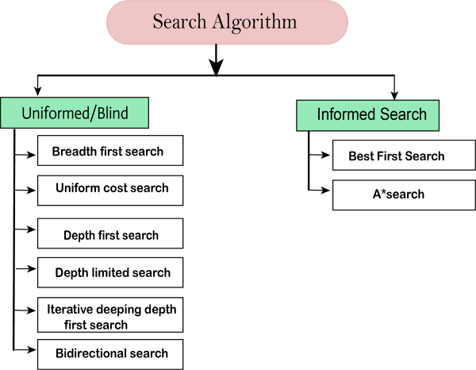

### Uninformed/Blind Search:

The uninformed search does not contain any domain knowledge such as closeness, the location of the goal. It operates in a brute-force way as it only includes information about how to traverse the tree and how to identify leaf and goal nodes. Uninformed search applies a way in which search tree is searched **without any information about the search space like initial state operators and test for the goal**, so it is also called blind search.It examines each node of the tree until it achieves the goal node.

**It can be divided into five main types:**

* Breadth-first search
* Uniform cost search
* Depth-first search
* Iterative deepening depth-first search
* Bidirectional Search

### Informed Search

Informed search algorithms use domain knowledge. In an informed search, problem information is available which can guide the search. Informed search strategies can find a solution more efficiently than an uninformed search strategy. Informed search is also called a Heuristic search.

A heuristic is a way which might not always be guaranteed for best solutions but guaranteed to find a good solution in reasonable time.

Informed search can solve much complex problem which could not be solved in another way.

An example of informed search algorithms is a traveling salesman problem.

1. Greedy Search
2. A* Search

# Uninformed Search Algorithms

**Uninformed search is a class of general-purpose search algorithms which operates in brute force-way. Uninformed search algorithms do not have additional information about state or search space other than how to traverse the tree, so it is also called blind search.**

**Following are the various types of uninformed search algorithms:**

1. **Breadth-first Search**
2. **Depth-first Search**
3. **Depth-limited Search**
4. **Iterative deepening depth-first search**
5. **Uniform cost search**
6. **Bidirectional Search**

## 1. Breadth-first Search:

* Breadth-first search is the most common search strategy for traversing a tree or graph. This algorithm searches breadthwise in a tree or graph, so it is called breadth-first search.
* BFS algorithm starts searching from the root node of the tree and expands all successor node at the current level before moving to nodes of next level.
* The breadth-first search algorithm is an example of a general-graph search algorithm.
* Breadth-first search implemented using FIFO queue data structure.

**Advantages:**

* BFS will provide a solution if any solution exists.
* If there are more than one solutions for a given problem, then BFS will provide the minimal solution which requires the least number of steps.

**Disadvantages:**

* It requires lots of memory since each level of the tree must be saved into memory to expand the next level.
* BFS needs lots of time if the solution is far away from the root node.